Geethanjali College of Pharmacy
Approved by PCI New Delhi, Permanently Affiliated to JNTUH,
Accredited by NAAC A+ Grade, NBA (B. Pharmacy), NIRF,
Recognized Under UGC Section 2F & 12B of UGC Act, 1956, DSIR-SIRO,
HI/BI of MSME & ISO 9001:2015 Certified, AMC of PvPI.
Cheeryal (V), Keesara (M), Medchal-Malkajgiri Dist., Telangana State- 501301

Report on National Education Day

On November 10th 2023, the Department of Pharmaceutical Chemistry and Analysis at Geethanjali College of Pharmacy celebrated National Education Day in honour of Maulana Abul Kalam Azad's birthday. In his remarks on National Education Day, Principal Dr. M. Ravikumar offered guidance and inspiration to both educators and students.

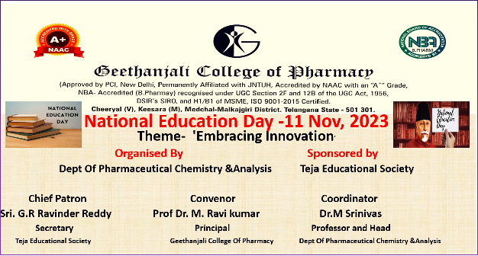

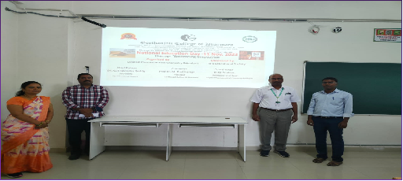

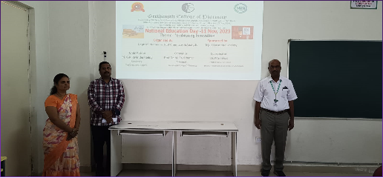

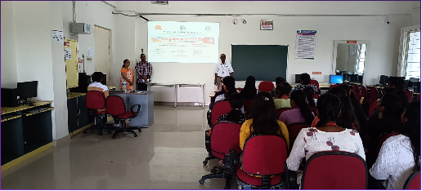

Geethanjali College of Pharmacy
Approved by AICTE, PCI New Delhi, Permanently Affiliated to JNTUH & Accredited by Naac With A+ grade, NBA Accredited by (B. Pharmacy) Recognized Under UGC Section 2F & 12B of UGC Act, 1956, by DSIR-SIRO & HI/BI of MSME, Certified by ISO 9001:2015
Cheeryal (V), Keesara (M), Medchal-Malkajgiri Dist., Telangana State- 501301
Attendance sheet on National Education Day
1 | Alladurgam Navya
2 | Amadala Urian Raj
3 | Amula Varsha
4 | Ananthoju Divya
5 | Arumalla Krishna Praveen Reddy
6 | Babburi Sowmya
7 | Baki Narahari
8 | Balagani Aswini
9 | Balam Poojitha Priyamvadh
10 | Banala Vamshitha Reddy
11 | Bondugula Karunya Reddy
12 | Boompagu Chitra
13 | Dara Apoorva
14 | Dupati Sruthi
15 | Fariya Khulood
16 | Gadagoni Sai Teja Goud
17 | Gannegoni Varsha Goud
18 | Golla Nandini
19 | Gujja Vaishnavi
20 | Pallapu Praveen Kumar
21 | Pinreddy Nikhila Reddy
22 | Pittala Preethi
23 | Podagatlapalli Srinivasa Phani Rithwik
24 | Gadagoni Sai Teja Goud
25 | Gannegoni Varsha Goud
26 | Golla Nandini
27 | Gujja Vaishnavi
28 | Pallapu Praveen Kumar
29 | Pinreddy Nikhila Reddy
30 | Pittala Preethi

Principal Head Of The Department Organizer

